The Competence, Motivation, Human Resources Management And Leadership Style Effect On Employee Performance At The Education Office
Of Tangerang District

Eko Warso¹*, A. Azis Wahab², Achmad Mudrikah³, M. Andriana Gaffar⁴

^{1,2,3,4} Doctoral Program, Nusantara Islamic University, Indonesia
* Corresponding author:
Email: ekowarso54@gmail.com

Abstract.
The purpose of this study was to examine the effect of competence, motivation, human resource management and leadership style on employee performance (a case study on employees of the Tangerang Regency Education Office. The analytical method used is descriptive quantitative method with multiple correlation and multiple regression approaches and uses the program SPSS version 25.0 Based on the results of the data analysis equation, the regression obtained is as follows:
Y = 15,414 + 0.486X1 + 0.261X2 - 0.221X3 + 0.346 X4.
Based on hypothesis testing using the T test that leadership style and motivation have a positive and significant effect on employee performance. The results of the study simultaneously using the F test, showed that all independent variables had a significant effect on employee performance. The correlation coefficient value is 0.613. With these results, it is found that there is a strong correlation for the influence of competence, motivation, human resource management and leadership style on the performance of Tangerang Regency Education Office employees, because the coefficient value is between 0.50 to 0.75. While the value of the coefficient of determination of the performance of the Tangerang Regency Education Office employees is shown by the Adjusted R Square value of 0.327, this means that the contribution of the influence of competence, motivation, human resource management and leadership style on the performance of Tangerang Regency Education Office employees is 32.7% while the remaining 67.3% is influenced by other variables. Outside the variables studied.
Keywords: Competence, motivation, human resource management, leadership style, employee performance

- INTRODUCTION
Human resources have a big role in an organization, especially to achieve organizational goals. Success in achieving organizational goals is fully supported by the attitudes and behavior of employees, employees have an important role in shaping and managing organizations and utilizing existing technology. In fact, the success of an organization is determined by the leadership developed in the organization and the competencies, human resources possessed by members and the motivation given to all members or subordinates to achieve these goals. This is because every leader must have a good relationship with his subordinates.Employees are the main asset of the organization and have a strategic role in the organization as thinkers, planners, and controllers of organizational activities. In order to achieve organizational goals, employees need competence, motivation, human resource management to work more diligently and have quality and quantity performance so that they will make a positive contribution to organizational development. In addition, organizations need to pay attention to various factors that can affect employee motivation in improving work discipline and leadership styles, which are conducive to encouraging the creation of professional attitudes and actions in completing work in accordance with the fields and responsibilities of each employee. Leaders must ensure that subordinates' performance is properly rewarded, and not otherwise ignore and do not give positive rewards for subordinates' performance.The low performance of employees, motivational competence, human resources faced by employees are problems that must be discussed. Motivation can influence someone or give encouragement to someone to do something.At the SKPD of the District Education Office. Tangerang, a government institution, certainly has a Strategic Plan tied to its main tasks and functions in the field of education.
The plan is divided in the form of a Work Plan whose role is to carry out activity targets and achievements at the beginning of the activity year which aims to discuss the financial budget of activities and when activities are held. After the activities are carried out, each employee evaluates the organization's performance in the form of control meetings which are held every month. In this control, it is reported that the performance achievements of each field include Physical Targets and Financial Realization in the form of Percentages. The difference that occurs is poured in the form of the magnitude of the deviation. As a measuring tool of the results of the Organizational Work Plan achieved.In achieving organizational goals, every organization needs resources to achieve them. These resources include natural resources, financial resources, scientific and technological resources, and human resources. Among these resources, the most important resource is human resources. Human resources are a very valuable asset or a large investment that will be the main factor that determines the success of an organization. Thus, without human resources, other resources will be idle and less useful in achieving organizational goals. Human resources are a partner that determines the growth and development of an organization.Competence is a fundamental characteristic of each individual that is associated with criteria that are referenced to superior or effective performance in a job or situation. According to Spenser and Spenser in Wibowo (2007:87) stated that competence is the basic foundation of people's characteristics and indicates how to behave or think, equate situations, and support for a long period of time.According to Simanjuntak (2005:113), competence is not only contained skills, knowledge, and attitudes, but how to apply them in accordance with performance standards. Competence can deepen and broaden work abilities. The more often someone does the same job, the more skilled and faster he will complete the job. The more kinds of work a person does, the richer and wider his work experience is, and it allows for increased performance.
1906
Sutrisno (2011; 203) explains that the notion of competence in public and private organizations is needed, especially to answer the demands of the organization, where there are very fast changes, the development of very complex and dynamic problems and the uncertainty of the future in the order of people's lives. Competence is an ability based on skills and knowledge that is supported by work attitudes and their application in carrying out tasks and work in the workplace that refers to the work requirements set.Humans behave in doing something because of the driving factor from within the human itself or better known as the motive. Human behavior is essentially goal-oriented. Motivation is the process of giving work motives to employees so that they want to work for the achievement of organizational goals effectively and efficiently. With the fulfillment of all needs or desires and expectations, employees will get satisfaction, and employees with high levels of satisfaction will automatically increase their performance.Veithzal (2010: 837), motivation is a series of attitudes and values ​​that influence individuals to achieve specific things according to individual goals. These attitudes and values ​​are an invesible which provide the strength to encourage the individual to behave in achieving goals. If individuals are motivated, they will make positive choices to do something, because basically motivation can spur employees to work hard so that they can satisfy their desires and increase their work productivity and will ultimately affect the achievement of organizational goals.According to Handoko, (2012: 250) Motivation is a condition in a person's personality that drives the individual's desire to carry out certain activities in order to achieve goals. So the motivation that exists in a person is the driving force that will realize a behavior in order to achieve the goal of self-satisfaction.Motivation is formed from the attitude of an employee in dealing with work situations that move employees who are directed to achieve organizational goals (work goals). Motivation is a person's desire to do something due to encouragement from himself or from outside the employee. In addition, motivation can also be interpreted as an encouragement for employees to take action because they want to do it.
According to Bintoro and Daryanto (2017: 15) stated that "Human resource management, abbreviated as HRM, is a science or method of how to regulate the relationship and role of resources (labor) owned by individuals efficiently and effectively and can be used optimally so that achieve the common goals of the company, employees and society to be maximized”.This is undeniable because all activities in the organization to achieve the targets of success and organizational goals depend on the people who manage them. The success of a company is largely determined by the quality of human resources (HR) in it. Human Resources (HR) is one of the resources contained in the organization, which includes all people who carry out activities within the organization or company (Faustino: 2003).Of all the resources available in an organization, both private and public organizations, human resources are the most important and very decisive and very influential on the organization's efforts in achieving its goals. No matter how advanced technology, the development of information, the availability of working capital, but without human resources it will be difficult for the organization to achieve its goals. Therefore, the organization must build and focus on Human Resources (HR) to improve job performance in carrying out all the work that is within the scope of the organization. According to Herman Sofyandi (2013:6) states that "HR management is defined as a strategy in implementing management functions, namely planning, organizing, leading and controlling, in every HR operational activity/function starting from the process of withdrawal, selection, training and development, placements which include promotions, demotions and transfers, performance appraisals, compensation, industrial relations, and termination of employment, which are shown to increase the productive contribution of the organization's human resources towards achieving organizational goals more effectively and efficiently”.The leadership style factor is also believed to affect the performance of employees at the Tangerang District Education Office. The main role of leadership style is to be able to influence others to work together seriously in achieving organizational goals. The role of superiors or often called leaders is very large for the success of the organization in achieving its goals. From them emerged new and innovative ideas in organizational development. In reality, not all leaders behave well or are able to create a conducive and familial working atmosphere, many leaders in their leadership are selfish, do not want to be cooperative, do not want to sacrifice and do not want to provide encouragement to encourage employees to work. Ineffective leadership and lack of attention to employees usually cause employees' feelings of displeasure towards superiors which are manifested in the form of being lazy at work and less enthusiastic in responding to every task given by the leadership.
1907
According to Thoha (2013: 49) that Leadership Style is a behavioral norm used by a person when that person tries to influence the behavior of others as he sees it, while Rivai (2014: 42) states that Leadership Style is a set of characteristics used by leaders to influence subordinates. so that organizational goals are achieved or it can also be said that leadership style is a pattern of behavior and strategies that are preferred and often applied by a leader. A leadership style that shows, directly or indirectly, about a leader's belief in the abilities of his subordinates. This means that leadership style is behavior and strategy, as a result of a combination of philosophies, skills, traits, attitudes, which a leader often applies when he tries to influence the performance of his subordinates.At the District Education Office. Tangerang which has the main task of carrying out the preparation of formulations, technical policies, coaching, coordinating the implementation of integrated tasks, and administrative services for the office environment, as well as implementing program, financial, and general affairs and personnel. District Education Office. Tangerang in carrying out these main tasks, there are obstacles in carrying out the main tasks, namely a decrease in employee performance. not only from the results of financial absorption data, the results of the attendance recap of the Tangerang Regency Education Office also showed a decline which can be proven from the results of the percentage of attendance recap. In the results of the attendance recap, every month an attendance evaluation is carried out. From the results of the attendance recap, it can be measured where the employee's performance has decreased or increased every month. This decrease could be because the implementation of attendance still uses a manual system (with attendance signatures) so that employees often do not attend attendance, it can be caused by forgetting, or intentionally such as going home early, arriving late, not logging in without permission and so on. Where absenteeism affects the size of the Income Improvement Allowance that will be received by civil servants every month. And in terms of completing the tasks assigned to each field based on a letter that went to the District Education Office.
Tangerang employees are able to do several jobs or tasks that will be close to the time, if there is still a long time to submit the task then the employee can do tasks that will approach the time of submission. In terms of employee performance, of course, it must be immediately updated so that the SKPD employees of the District Education Office. Tangerang can provide excellent service to the community in a more professional manner.Nasdir, Hasan Nongkeng and Budiman in their 2017 research entitled The Influence of Competence, Leadership Style, and Motivation on Employee Performance at the Bantaeng Regency Transportation Office proves that Competence, Leadership Style, and Motivation have an effect partially or simultaneously. The variables of Competence, Leadership Style, and Motivation partially have T values ​​of 2.126 (X1), 2.339 (X2), 2.298 (X3) with significant values ​​<0.05 each of 0.045 (X1), 0.000 (X2 ), 0.004 (X3). The results of the F test with Fcount 21,630 and a significance of 0.000. These results prove that competence, leadership style, and work motivation simultaneously have a positive effect and all have a significant effect on employee performance. From the results of the Adjusted R2 test of 0.662, which means that the variables of Competence, Leadership Style, and Motivation affect employee performance variables by 66.2% and the remaining 33.8% is influenced by other variables not included in this study. The regression equation obtained is Y = 0.981 + 0.285 X1 + 0.389 X2 + 0.333 X3.Siti Sukmawati S and Roslina Alam in their 2019 research entitled The Effect of Motivation, Leadership and Competence on Employee Performance at the Makassar City Bappeda Office proved that Motivation, Leadership and Competence have an effect partially or simultaneously. In the variable of Motivation, Leadership and Competence partially have T values ​​of 4.003 (X1), -3.602 (X2), 5.768 (X3) with significant values ​​<0.05 each of 0.000 (X1), 0.001 (X2) , 0.000 (X3). The results of the F test with Fcount 25,193 and a significance of 0,000. These results prove that Motivation, Leadership and Competence simultaneously have a positive effect and all of them have a significant effect on employee performance. From the results of the Adjusted R2 test of 0.597 which means that the variables of Motivation, Leadership and Competence affect employee performance variables by 59.7% and the remaining 40.3% is influenced by other variables not included in this study. The regression equation obtained is Y = 0.223 + 0.426 X1 + 0.065 X2 + 0.567 X3.Sentosa Karo-Karo and Sastra Tamami in their 2016 research entitled The Effect of Human Resource Development and Leadership Style on Employee Performance at BP Hospital.
1908
Batam proves that Human Resource Development and Leadership Style influence partially or simultaneously. In the Human Resource Development and Leadership Style variables partially have T values ​​of 1.002 (X1), 7.733 (X2) with a significant value <0.05 each of 0.30 (X1), 0.001 (X2). F test with Fcount 96,742 and significance 0.000. These results prove that Human Resource Development and Leadership Style simultaneously have a positive effect and all have a significant effect on employee performance. From the results of the Adjusted R2 test of 0.735, which means that the Human Resource Development and Leadership Style variables affect the employee performance variable by 73.5% and the remaining 26.5% is influenced by other variables not included in this study. The regression equation obtained is Y = 5.607 + 0.098X1 + 0.769X2.After looking at the description of the background and some relevant research above, the author wants to conduct a study with the title "The Influence of Competence, Motivation, Human Resource Management and Leadership Style at the Tangerang Regency Education Office". The problem to be solved in this research is "How is the Partial Effect of Competence on Employee Performance at the Tangerang Regency Education Office?" How is the partial effect of motivation on employee performance at the Tangerang Regency Education Office?”. How is the partial influence of Human Resource Management on Employee Performance at the Tangerang Regency Education Office?”. How is the partial influence of leadership style on employee performance at the Tangerang Education Office?”. How does the simultaneous influence of Competence, Motivation, Human Resource Management and Leadership Style on Employee Performance at the Education Office of Tangerang Regency? The purpose of this study is expected to be a material consideration for the Tangerang Regency Education Office and other government agencies to determine policies that can encourage employee performance improvement.

II. METHODS
The research was conducted at the Tangerang Regency Education Office Jalan H. Abdul Hamid, Tangerang Regency Government Office Complex, Tigaraksa Tangerang, Banten 15720. The research method used is a questionnaire method with correlational analysis techniques. This correlational analysis technique is used to measure the relationship between Competence (X1), Motivation (X2), Human Resource Management (X3), and Leadership Style (X4) with Employee Performance (Y), either individually or together. The relationship between the related variable (Y) and the independent variable (X1; X2; X3, X4) can be seen in the constellation model below:
1909
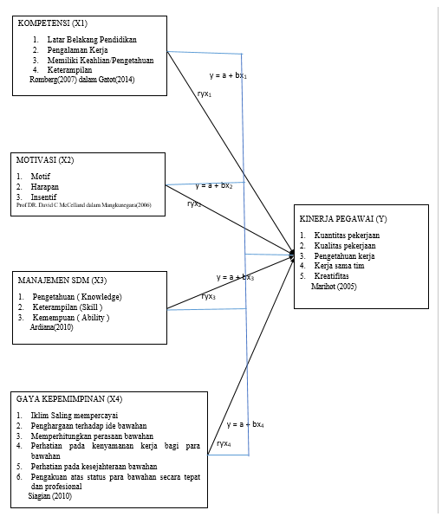
Fig 1.Problem Constellation Model
Information :
X1 = Competence
X2 = Motivation
X3 = Human Resource Management
X4 = Leadership Style
Y = Employee Performance

To determine whether or not there is an influence between Competence, Motivation, Human Resource Management and Leadership Style, with employee performance, four predictor regression analysis techniques are used. The equation for the regression line of the four predictors is:

Y = a + bX1 + cX2 + dX3 + eX4
description :
a = Constant
b, c, d, e = Coefficient of Competence, Motivation, Human Resource Management, Leadership Style
The t test is to prove and determine the effect of Competence, Motivation, Human Resource Management and Leadership Style on Employee Performance with a significant level of 5%. If the t-test is obtained with a probability of <0.05, then H0 is rejected and Ha is accepted, which means that there is a significant influence between Competence, Motivation, Human Resource Management and Leadership Style on Employee Performance.
(1) H0 : = 0, there is no partial effect between the independent variables on the dependent variable
(2) Ha : > 0, there is a positive and partially significant effect between the independent variables on the dependent variable.
With the following criteria:
(1) Significant level of 0.05
(2) If tcount < ttable then H0 is accepted and Ha is rejected
(3) If tcount > ttable then H0 is rejected and Ha is accepted
1910
In addition to performing the t test, it is also necessary to find the magnitude of the partial coefficient of determination (r2) for each independent variable. This partial determination test (r2) is used to find out how much the contribution of each independent variable to the dependent variable is.In this research, the value of r2 is searched by using the computer assistance program SPSS for Windows Release 25.0.

III. RESULT AND DISCUSSION
Multiple linear regression analysis was used to see the effect of the independent variables on the dependent variable. The independent variables used in this study were competence, motivation, human resource management and leadership style, while the dependent variable in this study was performance. To see the effect of competence, motivation, human resource management and leadership style on the performance of Tangerang Regency Education Office employees, it can be seen in the following table:
Table 1 Multiple Linear Regression Analysis Results
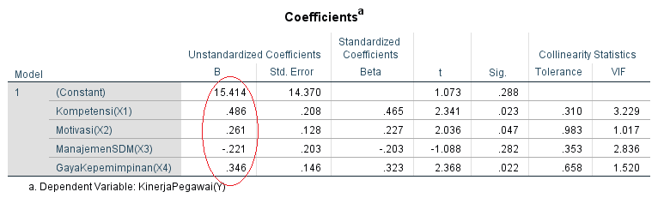
Source: Attachment of Data Processing Results, 2021
Based on table 1, multiple linear regression equations can be made as follows:
Y = 15,414 + 0.486X1 + 0.261X2 - 0.221X3 + 0.346 X4
From the above equation, several things can be interpreted, as follows: 1) The constant is 15,414, meaning that if the competence, motivation, human resource management and leadership style (X1=X2=X3=X4=0) are getting better, then the employee's performance will be better too; 2) The coefficient of competence is 0.486, which means that competence has a positive effect on the performance of the Tangerang Regency Education Office employees, where if the competency increases by one unit, the Tangerang Regency Education Office's employee performance will increase by 0.486 units; 3) The coefficient of motivation is 0.261, which means that partially motivation has a positive effect on the performance of the Tangerang Regency Education Office where if motivation increases by one unit, the Tangerang Regency Education Office's employee performance will increase by 0.261 units; 4) The coefficient of human resource management is -0.221 and is negative, which means that if the Human Resource Management variable decreases by 1 unit, then the dependent variable, namely Employee Performance, will also decrease by -0.221 and vice versa; 5) The coefficient of leadership style is 0.346, meaning that partially leadership style has a positive effect on the performance of the Tangerang Regency Education Office where if the leadership style increases by one unit, the Tangerang Regency Education Office's employee performance will increase by 0.346 units; 6) There is a significant influence between competence, motivation, human resource management and leadership style that affect the performance of the Tangerang Regency Education Office employees. Tangerang District Education.
The output results of SPSS correlation coefficient analysis for the influence of Competence, Motivation, Human Resource Management and Leadership Style on the performance of Tangerang Regency Education Office employees can be seen in the table below:

1911
Table 2. Correlation Coefficient Analysis Results
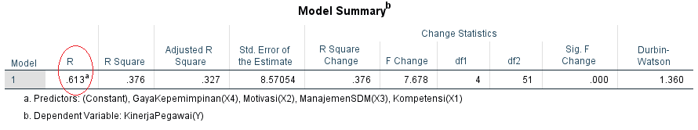
Source: Attachment of Data Processing Results, 2021
From table 2 above, it can be seen that the correlation coefficient value is 0.613. With these results, it is found that there is a strong correlation for the influence of competence, motivation, human resource management and leadership style on the performance of the Tangerang District Education Office, because the coefficient value is between 0.50 to 0.75.Based on table 4.19, the coefficient of determination of the performance of the Tangerang Regency Education Office employees is shown by the Adjusted R Square value of 0.327, this means that the contribution of the influence of competence, motivation, human resource management and leadership style on the performance of the Tangerang Regency Education Office employees is 32, 7% while the remaining 67.3% is influenced by other variables.The t-test is used to see the effect individually between the independent variable and the dependent variable. With the help of the SPSS V.25 program, it is known that the t-count value in table 4.20 is as follows
Table 3. Partial t-test results
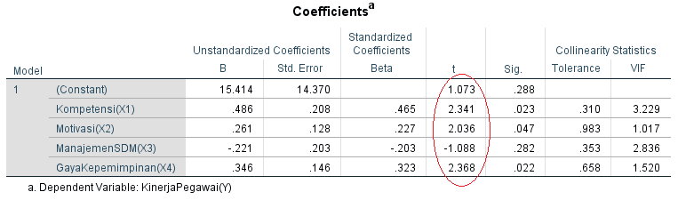
The calculated F value in the Anova table is as follows:
Table 4
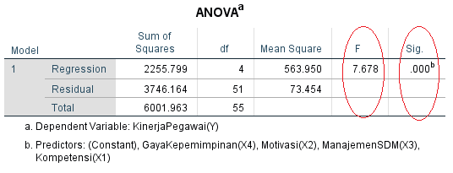
Based on the table above, the t-test can be explained as follows: 1) The coefficient of competence quality variable with a t-count value of 2.341 and a value (sig=0.045<0.05). With df = 56-4-1 = 51 obtained ttable of 1.675, from the above results it can be seen that tcount> ttable or 2,341count> 1.675table, then the competence variable has a significant influence on the performance of the Tangerang Regency Education Office employees; 2) The coefficient of motivation variable with a t value of 2.036 and a value (sig = 0.007 <0.05). With df = 56-4-1 = 51 obtained ttable of 1.675 from the results above it can be seen that tcount> ttable or 2,036count> 1,675table, then the motivation variable has a significant influence on the performance of the Tangerang Regency Education Office employees; 3) The coefficient of human resource management variable with a t value of 1.088 and a value (sig = 0.007 <0.05). With df = 56-4-1 = 51 obtained ttable of 1.675 from the above results it can be seen that tcount> ttable or 1,088count<1.675table, then the human resource management variable has no partial significant effect on the performance of the Tangerang Regency Education Office employees; 4) The coefficient of leadership style variable with a t value of 2,368 and a value (sig = 0.000 <0.05).
1912
With df = 56-4-1 = 51 obtained ttable of 1.675 from the above results it can be seen that tcount> ttable or 2,368count> 1,675table, then the leadership style variable has a significant influence on the performance of the Tangerang Regency Education Office employees; 5) Based on the F test, it is known that the calculated F value is 7,678 with a significance value of 0.000 (p <0.05). This means that together the variables of competence, motivation, human resource management and leadership style have a positive and significant influence on the performance of the Tangerang Regency Education Office employees. The correlation coefficient value is 0.613. With these results, it was found that the strong influence for the influence of competence, motivation, human resource management and leadership style on the performance of the Tangerang Regency Education Office employees, because the coefficient value was between 0.50 to 0.75. The value of the coefficient of determination of the performance of the Tangerang Regency Education Office employees is shown by the Adjusted R Square value of 0.327, this means that the contribution of the influence of competence, motivation, human resource management and leadership style on the performance of Tangerang Regency Education Office employees is 32.7% while the rest 67.3% influenced by other variables

IV. CONCLUSION
The coefficient of competence variable with a tcount value of 2,341 and a value (sig=0.045<0.05). It can be concluded that partially there is a significant influence between competence on the performance of the Tangerang Regency Education Office employees. The better the competence of an employee in an agency, the better at his job. Competence means the ability that must be possessed by a person or every worker to be able to carry out a job effectively, efficiently, productively and with quality in accordance with the vision and mission of the organization. An employee who has good competence will make employees more careful in trying to achieve the expected targets, this has an impact on their performance through employee morale.The coefficient of motivation variable with a t-count value of 2.036 and a value (sig=0.045<0.05). It can be concluded that partially there is a positive and significant influence between motivation on the performance of the Tangerang Regency Education Office employees. The better the motivation of a person in an agency, the more employees will enjoy their work. Motivation means the ability that can direct employees to organizational goals so that they have a strong desire to work and strive so that the wishes of employees and organizational goals can be achieved. A leader who is able to motivate employees to work better, this will make employees more careful in trying to achieve the expected targets, this has an impact on employee performance.The coefficient of the Human Resource Management variable with a t value of -1.088 and a value (sig = 0.000 <0.05). It can be concluded that partially there is no significant influence between Human Resource Management on the performance of Tangerang Regency Education Office employees. Human resource management is a management of human resources in an agency effectively and efficiently in order to help the realization of the goals of an organization
The coefficient of leadership style variable with a t-count value of 2.368 and a value (sig=0.045<0.05). It can be concluded that partially there is a positive and significant influence between leadership style on the performance of Tangerang Regency Education Office employees. The better a person's leadership style in an agency, the more employees will enjoy their work. Leadership means the ability to influence, move, and direct an action on a person or group of people for a particular purpose. In an effort to influence, a leader applies different styles in each situation. Leadership that is played well by a leader is able to motivate employees to work better, this will make employees more careful in trying to achieve the targets expected by the company, this has an impact on the performance of their employees.Based on the F test, it is known that the calculated F value is 7.678 with a significance value of (0.000 <0.05). So it can be concluded that simultaneously or simultaneously the variables of competence, motivation, human resource management and leadership style have a significant influence on the performance of the Tangerang Regency Education Office employees. The value of the coefficient of determination of the performance of the Tangerang Regency Education Office employees is indicated by an R value of 0.613, this means that the contribution of the influence of competence, motivation, human resource management and leadership style on the performance of Tangerang Regency Education Office employees is 61.3% while the rest is influenced by other variables.
1913

REFERENCES
- Abdullah, M. 2014. Manajemen dan Evaluasi Kinerja Karyawan. Yogyakarta : Aswaja Pressindo.
- Alorfi, Sabah. 2012. “Human Resource Management from an Islamic Perspektive,” Journal of Islamic and Human Advanced Research 2. 86-92
- Bangun, W. 2012. Manajemen Sumber Daya Manusia. Jakarta : Erlangga
- Chattab, N. 2007. Diagnosis Management : Upaya Peningkatan Keunggulan Organisasi, Jakarta : Serambi
- Dharma, S. 2012. Manajemen Kinerja Falsafah Teori dan Penerapannya. Yogyakarta : Pustaka Pelajar
- Earl, P. S. 2001. Manajemen Dasar, Pengertian, dan Masalah, edisi revisi, cetakan 1. Jakarta : Bumi Aksara
- Eckerson,W.W. 2009. Performance Management Strategies, Business Intelligent Journal, 14(1)
- Fahmi, I. 2011. Manajemen Kinerja. Bandung : Alfhabeta.
- Gibson, I, D. 1993. Organisasi, perilaku, Struktur dan proses, Edisi Kelima, Cetakan Ketujuh Terjemahan Djarkasih, Jakarta : Penerbit Erlangga
- Handoko, T. Hani. 2016. Manajemen Personalia dan Sumber Daya Manusia. Yogyakarta : BPFE
- Hursman, 2010, Human Resources Key Performance Indicators,” http://www.cjournal.cz/ files/89.pdf . (diakses pada tanggal 10 Februari 2021)
- Ilyas, Y. 2011. Kinerja, Teori, Penilaian dan Pelatihan. Jakarta : BP FKUM UI.
- Kartini K. 2013. Pemimpin dan Kepemimpinan, Jakarta: PT. Rajawali Grafindo Persada.
- L. Mathis, R & H. Jackson, J. 2011. Human Resource Management (edisi 10). Jakarta : Salemba Empat.
- Mangkunegara, A.P. 2013, Manajemen Sumber Daya Manusia Perusahaan, Bandung : Remaja Rosdakarya.
- Mulyasa, E. 2004. Kurikulum Berbasis Kompetensi; Konsep Karakteristik, dan Implementasi. Bandung: Rodya Karya.
- Nawawi, I. 2013. Budaya organisasi kepemimpinan dan Kinerja. Jakarta: PT. Fajar Iterpratama Mandiri.
- Owens, R G. 1987. Organizational Behavior in Education. New Jersey: Prentice Hall Inc.
- Pasolong, H. 2013. Teori Administrasi Pubilk. Bandung : Alfhabeta, CV.
- Rivai, V, dkk. 2014. Pemimpin Dan Kepemimpinan Dalam Organisasi. Jakarta : PT. Raja Grafindo Persada.
- Ruchanah, S. Kepemimpinan dalam Pendidikan Islam, M U A D D I B Vol.03 No.02 Juli-Desember 2013 ISSN 2088-3390
- Saksono, Slamet, 2003. Mitovasi dan Kepribadian, Edisi Kedua, Cetakan Ketiga, Jakarta : Mas Agung
- Sukardi. 2015. Metodologi Penelitian Pendidikan. Jakarta : PT Bumi Aksara
- Terry, G.R. 2013. Prinsip-prinsip Managemen. Jakarta : Bumi Aksara
- Wibowo. 2007. Manajemen Kinerja. Edisi Kedua. Jakarta : PT. Raja Grafindo Persada.
- Yani, M. 2012. Manajemen Sumber Daya Manusia. Jakarta: Mitra Wacana Media.
- Zainun, Buchori, 2000. Manajemen dan Motivasi. Edisi Revisi, Jakarta : Balai Aksara,

1914

